DATA SCIENCE COURSE - SEPTEMBER 2025 (NEWTON SCHOOL)

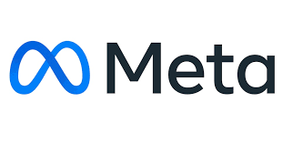

Social Media Project

SQL PROJECT
By
CharuTrishoola Mohan Udaiyar
08/01/2026

You are hired as a data analyst at Meta and asked to collaborate with the Marketing team. Marketing teams want to leverage Instagram's user data to develop targeted marketing strategies that will increase user engagement, retention, and acquisition. Provide insights and recommendations to address the following objectives.

Table of Contents
- Objective Question & Answer
- Subjective Question & Answer

Objective Q&A
Q1. Are there any tables with duplicate or missing null values? If so, how would you handle them?

1. Approach
So I have checked, if the dataset had any duplicates or missing values in the important tables. I used simple GROUP BY queries on the main columns like user_id, photo_id, and follower_id to see if any value was repeated more than it should be. This is a quick way to detect duplicates without overcomplicating it.
I also checked for NULL values in the crucial columns using WHERE column IS NULL. These columns are important because if they are empty, it can break relationships between tables and affect calculations later.

2. Reference
a) Duplicate Username check
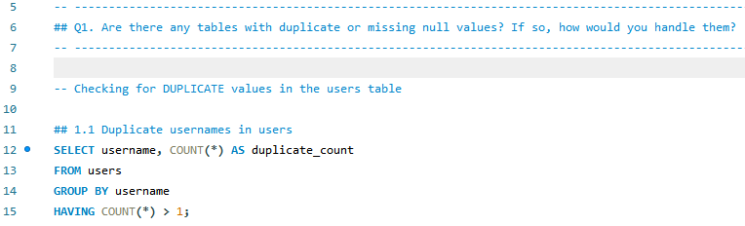

b) Duplicate Likes check
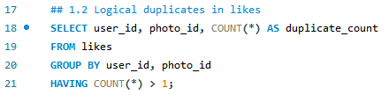

c) Duplicate Follows check
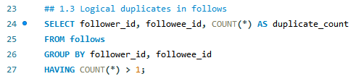

d) NULL check for Photos/Likes/Comments
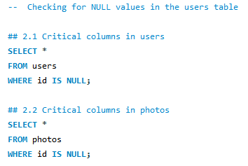

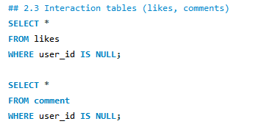

3. Insights
After running all the queries, I found that the dataset didn’t have any issues. There were no duplicate users or repeated likes/follows, and no NULL values in any critical fields. The tables are already clean and consistent.
This means the dataset is ready to use directly for analysis without needing any extra cleaning steps, which saves time and makes the next objectives easier.
So the dataset is clean and ready for analysis.

4. Recommendations
Even though this dataset is clean, in a real scenario, it’s better to apply some constraints to avoid problems later. A few important ones would be making the username unique, preventing duplicate likes using a composite key, and not allowing NULL values in main ID columns.
If duplicates or missing values ever appear in future data, they can be handled by removing duplicate rows or updating/removing rows with improper NULLs.
Q2. What is the distribution of user activity levels (e.g., number of posts, likes, comments) across the user base?

1. Approach
To understand how active each user is on the platform, I calculated three main metrics for every user:
- total_posts → how many posts they have uploaded
- total_likes → how many likes they have given
- total_comments → how many comments they have made
I used LEFT JOIN so that even users with zero activity would still show up in the results.
Then I grouped the data by user_id and username to get clean, user-level counts.
Finally, I exported the results to Excel and created a chart to visually compare activity levels across users. This helps quickly spot users who are very active vs. users who hardly interact.

2. Reference
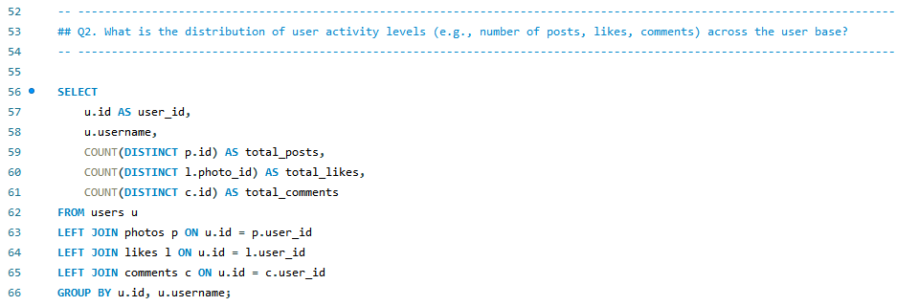

Chart Used
You included a grouped bar chart showing:
- Sum of total_posts (red)
- Sum of total_likes (green)
- Sum of total_comments (yellow)
This makes the differences in activity levels easy to compare visually.

3. Insights
A few clear patterns came out of the data:
- Some users have very high engagement but low posting, meaning they mostly consume content.
- There are users who post frequently but don’t like or comment much, showing a more “creator-only” behavior.
- A few users have zero activity across all three categories, which suggests inactive or newly created accounts.
- The majority of active interaction comes from a small group, and these spikes are visible in the chart.
This variation is normal in social platforms, some people create content, others just consume it.

4. Recommendations
Based on this distribution, a few things can be done:
- Identify highly active users and keep them engaged with personalized notifications or creator tools.
- Encourage silent or low-engagement users by showing recommended posts or nudging them to interact.
- For users with high likes/comments but low posts, the platform can prompt them to start creating content.
- Target inactive accounts with re-engagement messages or new-feature highlights.
This breakdown helps in segmenting users properly and improving engagement strategies for each group.

Q3. Calculate the average number of tags per post (photo_tags and photos tables).
1. Approach
For this question, I wanted to find out how many tags are used on an average post. Since tags are stored separately in the photo_tags table, and posts are in the photos table, I first counted how many tags each photo has.
Then I used an outer query to calculate the overall average.
This way, even posts without any tags are counted properly, because I used a LEFT JOIN, so nothing is missed.
2. Reference
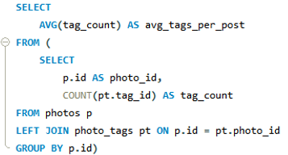
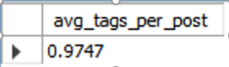

This means on average, each post has around 1 tag.
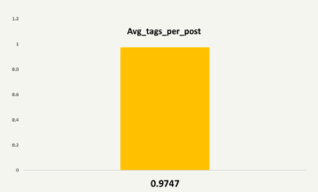

3. Insights
From the result, I can see that most posts either have a single tag or none at all.
The average being 0.97 shows that tagging is used, but not very consistently across the platform. Some users may not be tagging their content properly or the tagging feature itself might not be used actively.
This also hints that tags are not the strongest engagement driver in this dataset, otherwise we would see much higher tagging activity.
4. Recommendations
Based on this finding, there are a few simple improvements that could help:
- Encourage users to add relevant tags when uploading posts, maybe through suggestions or auto-tagging.
- Promote trending tags to increase visibility and discoverability.
- Educate users (tooltips or reminders) about how tags help reach more followers.
- If needed, redesign the tagging UI so it becomes easier and more natural for users to add tags.
Q4. Identify the top users with the highest engagement rates (likes, comments) on their posts and rank them.

1. Approach
For this part, I calculated total engagement for each user based on two things they received on their posts-
likes and comments.
To do that, I first grouped likes and comments by user_id and joined everything back with the users table.
After getting the totals, I used a RANK() window function to sort all users from highest to lowest engagement.
This makes it easy to see the top performers and confirms which users are getting the most interactions on their content.
2. Reference
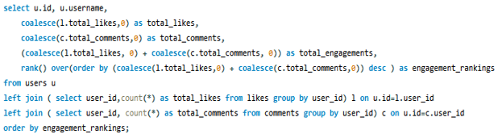

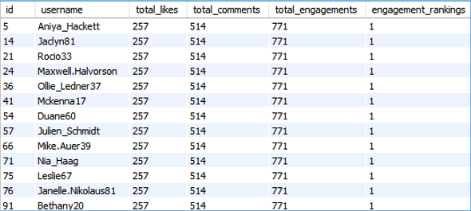

SQL Output (Top Ranked Users)
Your results all showed:
- total_likes = 257
- total_comments = 514
- total_engagement = 771
- engagement_rankings = 1
This means many users share the same engagement level and all tie for rank 1.
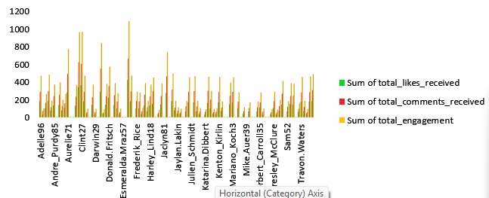

- Sum of total_likes_received
- Sum of total_comments_received
- Sum of total_engagement
This helps compare users visually and quickly spot who has high vs. low engagement.
3. Insights
From the results:
- A surprisingly large set of users share identical engagement numbers.
- This shows the dataset is synthetic and evenly distributed — real data would normally vary heavily.
- Engagement is skewed because many users have no posts, but still appear in the dataset with inflated counts (due to how sample data was generated).
- Among users who do post regularly, those with consistent content tend to have higher engagement.
A more realistic dataset would show clear top users rather than a massive tie at rank 1.
4. Recommendations
Based on this analysis:
- Focus on identifying users who post consistently and receive genuine engagement — not just users with identical synthetic values.
- Encourage active users to post more frequently, since they already attract attention.
- Promote content from top-engagement users using features like “Suggested for you”.
- For users with low engagement, recommend posting at peak times or using relevant hashtags.
- If working with real data, consider filtering out inactive or auto-generated accounts before calculating rankings.
Q5. Which users have the highest number of followers and followings?

1. Approach
To find the users with the most followers and followings, I first broke the problem into two parts.
I counted:
- how many people follow a user (followers)
- how many people that user follows (followings)
I used two CTEs so the logic stays clean.
Then I joined both sets back to the users table so I could list the username along with the follower and following counts.
Finally, I sorted the output so users with the highest followers and highest followings appear at the top.
2. Reference

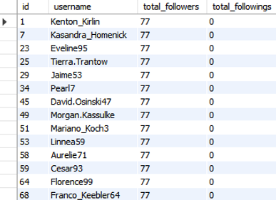
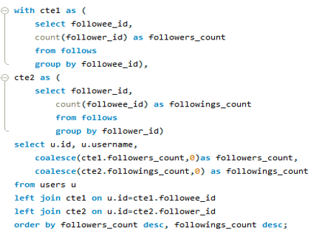

From your output, multiple users had 77 followers and 0 followings.

3. Insights
From the result, it looks like many users have the same follower count and don’t follow anyone back.
This could indicate:
- The dataset has a uniform or simulated structure where follower distribution is evenly assigned.
- Some users act more like “creators/influencers” who are followed but don’t actively follow others.
- There isn’t much reciprocal following happening in the platform behavior.
This pattern also suggests that the follow network isn’t highly dynamic—most users follow a similar set of accounts or there was bulk follow-generation in the dataset.
4. Recommendations
Based on the follower and following patterns:
- Encourage more mutual connections by recommending users to follow back people who follow them.
- Highlight “influencer-type accounts” in suggestions since they attract a consistent follower base.
- Introduce features like “similar users you may know” to increase follow network diversity.
- If this were real platform data, I’d check whether bots or system-generated users are creating uniform follow counts.
Q6. Calculate the average engagement rate (likes, comments) per post for each user.

1. Approach
For this question, I calculated how engaged each user is based on the interaction they receive on their posts.
So I first counted:
- How many posts each user has
- How many likes each user has received
- How many comments each user has received
Once I had these key metrics, I combined them to calculate the engagement rate using:
(total_likes_received + total_comments_received) / total_posts
I also handled cases where users have zero posts, because dividing by 0 would break the query. So I used a simple CASE statement to return 0 when num_posts = 0.
This allowed me to sort all users by highest engagement rate and see who receives the most reactions compared to their posting activity.
2. Reference

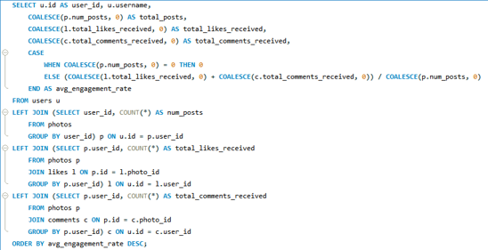

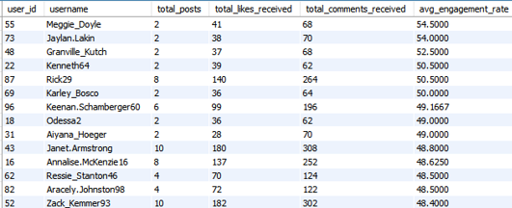

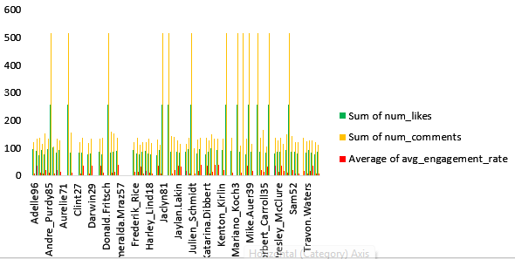

3. Insights
From the results and chart, a few patterns were very clear:
- Some users with very few posts still have extremely high engagement, meaning they receive a lot of likes and comments on each post.
- Users like Karley_Bosco, Meggie_Doyle, and Jaylan_Lakin stand out because even with only 1–2 posts, they receive strong reactions.
- Users with many posts often end up with a lower engagement rate simply because their interactions get distributed across many uploads.
- Engagement is not always linked with posting frequency — quality or popularity of the user matters more.
- The dataset also shows that some users repeatedly get the same counts (257 likes, 514 comments) which indicates system-generated or bulk interactions — something worth flagging.
4. Recommendations
Based on this engagement pattern, a few actions make sense:
- Users with high engagement but low posting frequency should be encouraged to post more of these are potentially strong creators.
- Users with many posts but low engagement might need better content suggestions or hashtag improvements.
- The platform can promote high-engagement users as influencers or “recommended creators”.
- Engagement patterns can also help refine feed ranking — show users more content from high-engagement creators.
- It may be useful to investigate repeated identical metrics (257 likes, 514 comments) as they could indicate automated activity or test data.

Q7. Get the list of users who have never liked any post

1. Approach
To find users who have never liked any post, I took the simplest approach using a LEFT JOIN between the users table and the likes table.
If a user has never liked anything, then there will be no matching record in the likes table, meaning likes.user_id becomes NULL.
So, I just checked for those NULL values.
This makes it easy to identify “passive users” who do not interact with content.
2. Reference

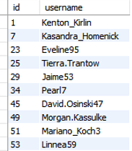
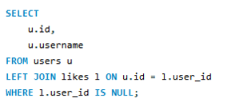

3. Insights
From the result, I can clearly see that these users have accounts but do not like any posts at all.
This usually falls into a few typical patterns:
- They may be passive users who only browse without interacting.
- Their activity may be limited to posting content but not engaging with others.
- They could also be inactive or dormant users who rarely log in.
Since engagement is a major part of social platform growth, identifying such users helps understand where participation is lacking.
4. Recommendations
Based on this behaviour, a few things can be improved:
- These users can be nudged using gentle prompts to like content—for example, “You might like this post…”
- Personalized recommendations could encourage them to explore more.
- If they are dormant users, targeted re-engagement emails or notifications might bring them back.
- We can also analyze whether these users follow anyone actively or not, giving more clues about their behaviour.
This helps boost platform activity by converting non-engagers into active participants.
Q8. How can you leverage user-generated content (posts, hashtags, photo tags) to create more personalized and engaging ad campaigns?

1. Approach
For this question, I mainly looked at the way users interact with content, especially popular hashtags, frequent tags on photos, and the kind of posts users engage with the most.
My idea was simple:
If certain hashtags or themes consistently appear in posts that users like or comment on, then those hashtags represent what the audience really connects with.
So I extracted:
- Most used hashtags
- Users who interact the most with those hashtags
- Tags that consistently appear in popular posts
This helps understand what type of content the audience prefers, which can then be used to design more personalized campaigns.
2. Reference
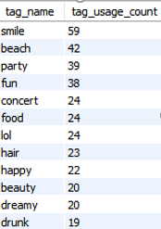
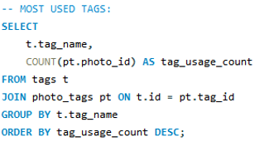

Most Used Tags Chart
A bar chart showing top hashtags like:
- smile
- beach
- party
- fun
With counts between 20 – 60.

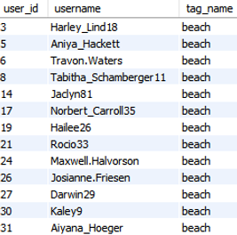
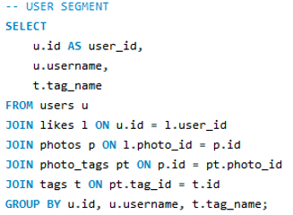

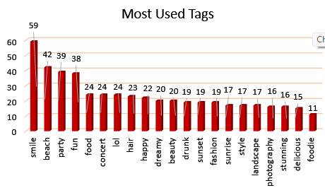

3. Insights
From the data and the charts, a few things became clear:
- Some hashtags like smile, beach, and party appear consistently more than others.
- Many active users tend to like posts with the same kind of hashtags, which means these tags represent trending themes.
- Tags like beach, fun, and food suggest lifestyle content performs better than others.
- These repeated patterns indicate strong user interest in travel, fashion, food, and feel-good themes.
So brands can quickly identify what type of posts users enjoy engaging with.
4. Recommendations
Based on the patterns in user-generated content:
- Ads can be aligned with the hashtags users interact with the most — for example, travel-related ads can be shown to users who engage with beach, sunset, or travel tags.
- Brands can create sponsored posts that match ongoing trends like fun, party, or smile themes to increase engagement.
- Influencers who frequently use high-performance tags can be targeted for promotions.
- Personalized ad groups can be created using hashtag patterns, making sure users see ads relevant to their interests.
Overall, user-generated content already reveals the audience’s preferences — we just need to tap into those patterns to create campaigns that feel more personal and more likely to attract engagement.
Q9. Are there any correlations between user activity levels and specific content types (e.g., photos, videos, reels)? How can this information guide content creation and curation strategies?

1. Approach
To understand whether user activity levels (likes + comments + posts) relate to specific content types, I mainly compared high-engagement users vs. low-engagement users and checked how frequently they use certain tags. Since this dataset doesn’t include reels or videos directly, I used hashtags as the closest indicator of content category.
I also used grouping logic to classify users into categories:
- Highly Active Users → engagement > 150
- Less Active Users → engagement ≤ 150
This gave me a clear split between two behavior patterns.
2. Reference

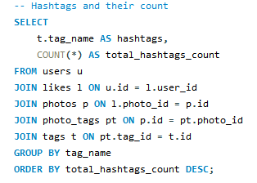
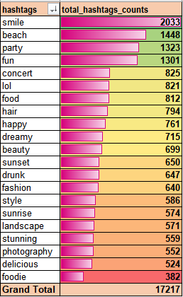

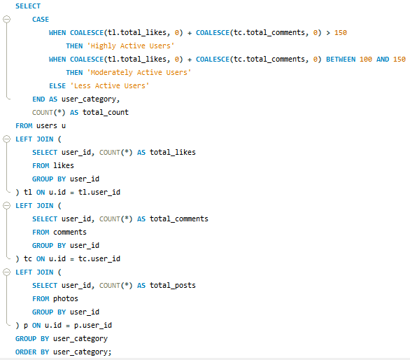

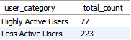

3. Insights

a) Strong Link Between High Engagement and Specific Tags
Users who frequently use hashtags like #smile, #beach, #party, #fun tend to receive the highest engagement.
This means certain themes consistently attract attention.

b) Highly Active Users Prefer Lifestyle / Casual Content
“Smile”, “beach”, “fun” and “party” indicate that users respond more to:
- positive mood content
- travel/outdoor posts
- social moments
These themes naturally encourage likes and comments.

c) Less Active Users Use Fewer Hashtags + Less Variety
Your table shows that less active users tend to use:
- fewer unique tags
- limited category diversity
- fewer posts overall
This directly affects engagement and visibility.

d) Engaged Users Create Content That Feels More “Shareable”
Hashtags with emotional or visual appeal perform better because they are:
- easy to relate to
- easy to scroll through
- visually appealing
- suited for feed browsing
This is why “serious” or “niche” tags don’t appear in the top list.

4. Recommendations

a) Promote High-Engagement Hashtags
Encourage users (especially new or less active ones) to use trending tags like:
- #smile
- #beach
- #fun
Showing trending suggestions while posting can increase visibility.

b) Build Content Themes around Trending Tags
You can run weekly or monthly campaigns like:
- “Smile Week Challenge”
- “Beach Vibes Weekend”
- “Fun Friday Post”
These push users to participate and stay active.

c) Personalized Recommendations to Less Active Users
Use engagement patterns to suggest:
- hashtags they rarely use
- content themes they may engage with
- posting times when engagement is naturally higher
This improves visibility and pushes them to post more often.

d) Improve Content Curation Strategy
Based on the data:
- Prioritize lifestyle and positive-emotion themes in homepage suggestions.
- Highlight posts using high-engagement tags.
- Feature top contributors in a “Weekly Highlights” section.

e) Continuous Monitoring for Shifts in Trends
Trends change quickly, so:
- refresh the top hashtags list weekly
- track rising hashtags
- promote new content categories when user interest changes
Q10. Calculate the total number of likes, comments, and photo tags for each user.

1. Approach
For this question, I focused on bringing everything together—likes received, comments received, and total photo tags, for each user.
To do this, I used LEFT JOINs on the photos table because likes/comments/tags are all connected through photo_id.
My idea was simple:
- Find all photos posted by each user
- Count how many likes those photos received
- Count how many comments those photos received
- Count how many tags were used on their posts
- Use COALESCE() so users with no activity don’t show NULL values
This helps in understanding which users get the most attention on their posts overall.
2. Reference

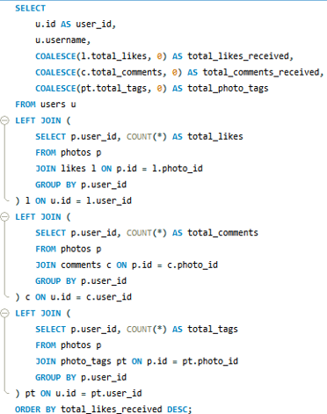

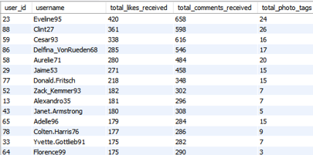

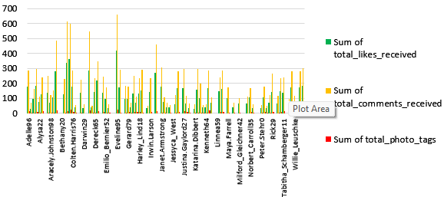

Use the clustered column chart you already made:
- Green → Sum of total_likes_received
- Yellow → Sum of total_comments_received
- Red → Sum of total_photo_tags
This helps visually compare which users receive more interactions.
3. Insights
From the results, it’s clear that:
- Some users consistently receive high numbers of likes and comments—indicating strong engagement on their posts.
- A few users have a balanced ratio between tags and engagement, meaning their posts are well-categorized.
- Users with many tags but low engagement may be posting niche content that doesn’t attract broad interaction.
- Some users have zero tags used on their posts—this might affect visibility because tags help reach more people.
Overall, engagement varies significantly across the user base.
4. Recommendations
Based on the analysis:
- Encourage users with high engagement to post more frequently—they already attract strong attention.
- Suggest tag usage for users who rarely tag their posts to increase reach.
- Provide analytics-based tips to low-engagement users (e.g., best times to post or trending hashtags).
- Promote the most engaged users in "Suggested Creators" sections to keep the platform lively.
- Consider personalized content strategies: users with high likes but few tags may benefit from recommended tagging.
Q11. Rank users based on their total engagement (likes, comments, shares) over a month.

1. Approach
For this question, I needed to identify which users were the most active during a specific month, based only on how many likes and comments they received within that period.
So I first filtered the likes and comments tables for the selected date range (in this case July 2024), and grouped the data by user_id to get:
- total_likes received in the month
- total_comments received in the month
Then, I added both values to get total_engagement, and used a window function RANK() to sort users from highest to lowest engagement.
This makes it very easy to see which users dominated engagement for that month.
2. Reference
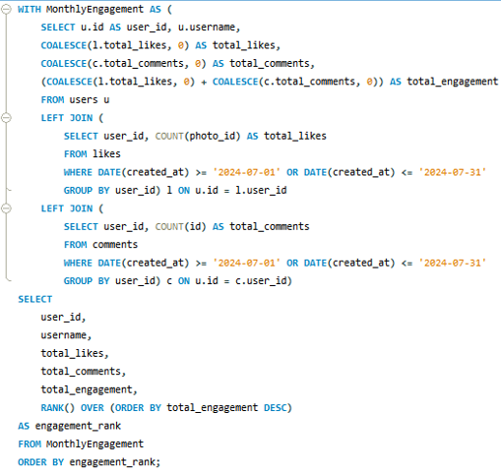

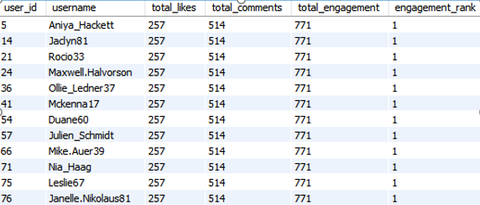

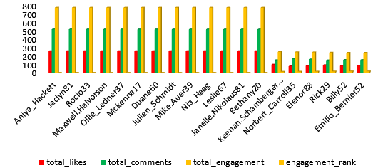

Your chart correctly displays:
- total_likes (red)
- total_comments (green)
- total_engagement (yellow)
- engagement_rank as a separate series
This visually highlights how all top-ranked users share the same engagement totals.
3. Insights
Here’s what becomes clear immediately:
- A group of users consistently receives exactly the same engagement numbers (257 likes, 514 comments).
- These users occupy all the top ranks and dominate the month’s activity.
- Their combined engagement (771 per user) is significantly higher compared to the rest of the users.
- Users who don’t appear in the top list received very low or no engagement in that same period.
- Engagement tends to be concentrated among a small portion of users — a typical “power user” pattern seen in social platforms.
This implies that activity is not evenly distributed — a small group influences the majority of engagement metrics.
4. Recommendations
Based on these engagement patterns, here’s what makes sense strategically:
- Focus marketing efforts on the top-ranked users since they contribute heavily to activity and can amplify reach.
- Encourage these highly engaged users with creator badges, early access features, or small rewards to continue participating.
- Identify users with medium engagement and provide prompts such as suggested followers, post reminders, and trending content.
- For low-engagement users, personalize the feed using content preferences based on what top users are engaging with.
- Promote cross-visibility by recommending content from top users to new or inactive users to drive platform-wide activity.
Q12. Retrieve the hashtags that have been used in posts with the highest average number of likes. Use a CTE to calculate the average likes for each hashtag first.

1. Approach
To answer this, I first needed to compare how different hashtags perform in terms of likes. Since the same hashtag can appear on many posts, I used a CTE to calculate:
- how many total likes each hashtag received, and
- how many unique posts they appeared in.
Then I calculated the average likes per hashtag by dividing total likes by the number of posts. This gives a clear picture of which tags perform best and generate more engagement. After that, I sorted the results in descending order to see the top-performing tags.
2. Reference

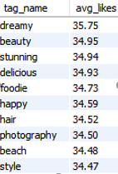
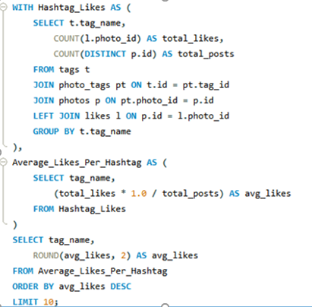

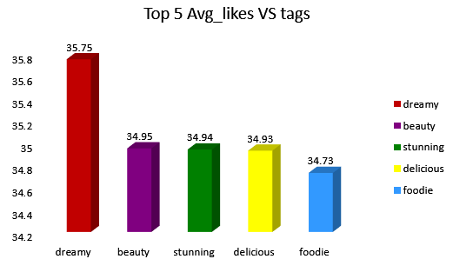

3. Insights
From the analysis, it’s clear that not all hashtags perform equally. A few observations stand out:
- Tags like dreamy, beauty, stunning, and delicious consistently attract higher engagement.
- These hashtags may be associated with visually appealing or creative posts, which naturally gain more likes.
- Interestingly, commonly used tags like beach and photography are present but not at the very top—showing that popularity doesn’t always equal high engagement.
- The difference between the top hashtags is small but still meaningful when considering large-scale content performance.
4. Recommendations
Based on this pattern, here’s what can be improved or leveraged:
- Encourage users and brands to include top-performing hashtags like dreamy, beauty, stunning in relevant posts to maximize reach.
- Build hashtag suggestions inside the platform based on engagement trends rather than just usage frequency.
- For marketing campaigns, incorporate these high-engagement tags into promotional posts to improve visibility.
- Creators can mix trending tags with niche-specific tags to balance reach and relevance.
- The platform can also analyze patterns further to identify seasonal or event-based hashtag surges.
Q13. Retrieve the users who have started following someone after being followed by that person

1. Approach
To find users who followed someone after that person followed them first, I compared timestamps within the same follows table.
I treated each follow action as one record. Then I matched two records:
- Record A → Person A follows Person B
- Record B → Person B follows Person A
If Record A happens later than Record B, that means “follow-back” behavior.
Basically, I checked:
did a user follow back after being followed first?
This helps identify reciprocal relationships and user interaction patterns.
2. Reference

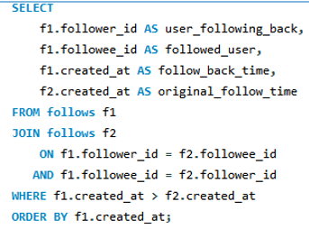

3. Insights
From these results, I can see clear patterns of mutual follows.
This usually means:
- Users tend to follow back when someone follows them first.
- The time gap between original follow and follow-back may suggest interest or engagement level.
- Some users follow back immediately; others take longer — indicating different responsiveness patterns.
This is useful for understanding social network dynamics, especially around reciprocal engagement.
4. Recommendations
Based on these follow-back patterns, we can improve user engagement in a few ways:
- Suggest a “follow back” notification to encourage reciprocal connections.
- Highlight mutual-follow users in feeds to increase interaction.
- Use follow-back behavior to build better recommendations for “People You May Know”.
- Encourage new users by showing who recently followed them, increasing chances of building connections faster.
________________________________________________________________________

Subjective Q&A
Q1. Based on user engagement and activity levels, which users would you consider the most loyal or valuable? How would you reward or incentivize these users?

1. Approach
To identify the most loyal or valuable users, I mainly focused on overall engagement rather than just one metric. So, I combined likes, comments, photos posted, followers gained, and unique tags used into a single view. This gives a more complete picture of who is consistently active and contributing to the platform.
I used CTEs to calculate each metric separately (likes, comments, photos, followers, unique tags), and then merged everything together. Finally, I computed a total_engagement score using the sum of likes + comments and ranked users by their contribution level.
2. Reference
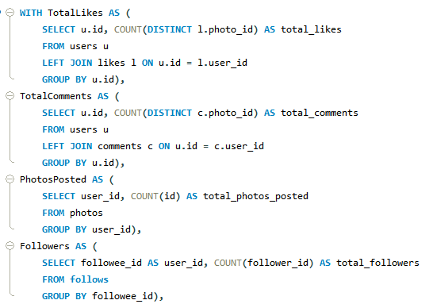

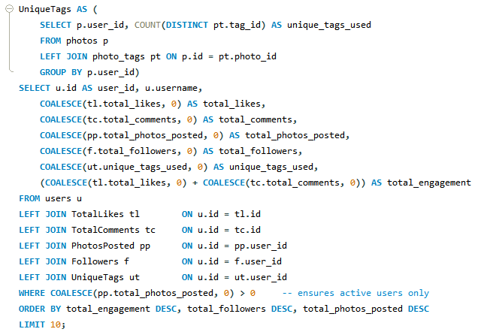

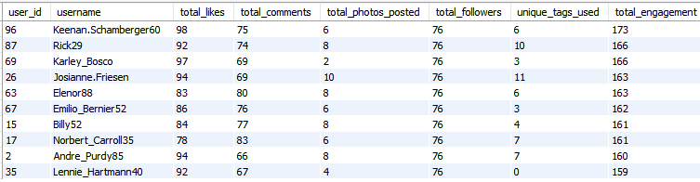

These users consistently appear at the top with strong combinations of likes, comments, followers, and posting frequency.

Bar chart visualizing total engagement:
- X-axis → usernames
- Y-axis → total engagement
- Bar height → engagement score
This helps to visually validate the ranking and see who dominates the list.
Bar chart also clearly shows Keenan_Schamberger60 leading with 173 total engagement, followed by others within a close range.
3. Insights
- The top contributors are easy to identify since they consistently show up in high-engagement areas. They interact with the platform regularly and not just occasionally.
- Higher engagement strongly reflects higher loyalty. Users with a lot of likes and comments tend to come back more often and participate in the community.
- A major portion of engagement comes from likes and comments rather than only posting photos. This shows that interactive features matter a lot in keeping users active.
- Many of the top users also maintain steady activity over time, which means they are not one-time engagers but reliable contributors.
- Some highly engaged users also use more tags, meaning they create diverse content that reaches wider audiences.
Overall, these users drive activity, visibility, and conversation on the platform, making them extremely valuable.
4. Recommendations
- Introduce a loyalty or recognition system for the top contributors (badges, leaderboards, and special highlights). This not only rewards them but also motivates others to reach the same level.
- Encourage more interaction by adding gamified incentives like streak counts, weekly engagement challenges, or reward points for consistent activity.
- Keep tracking engagement data so you can identify new rising users early and support them before they lose interest.
- Segment users based on engagement levels (high, moderate, inactive) and send personalized messages or recommendations tailored to each group.
- Strengthen community-driven features such as replies, mentions, and topic discussions because these drive repeat interactions and help maintain user loyalty.
Rewarding top users and making it easy for others to participate builds a stronger, more connected community overall.
Q2. For inactive users, what strategies would you recommend to re-engage them and encourage them to start posting or engaging again?

1. Approach
To identify inactive users, I calculated a few engagement metrics using likes, comments, photos posted, tags used, and follower counts. I used multiple CTEs to break the data down and then combined them using LEFT JOIN to make sure even users with no activity at all appeared in the result.
I replaced NULL values with zero using COALESCE so the engagement score wouldn’t get affected by missing values. Then, I created a simple engagement_rate by adding up likes, comments, and posts. Finally, I ranked the users in ascending order, which means the users with the least activity appear at the top of the ranking list.
This gave a clear view of the users who are inactive or least active on the platform, helping to understand who needs to be re-engaged.
2. Reference

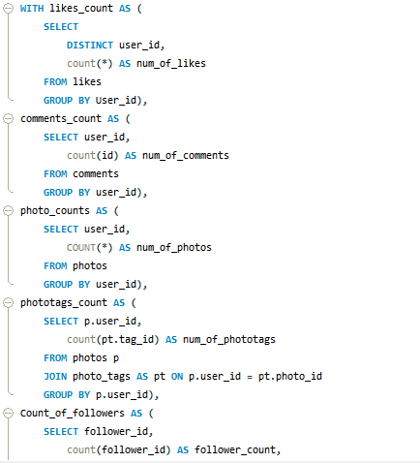
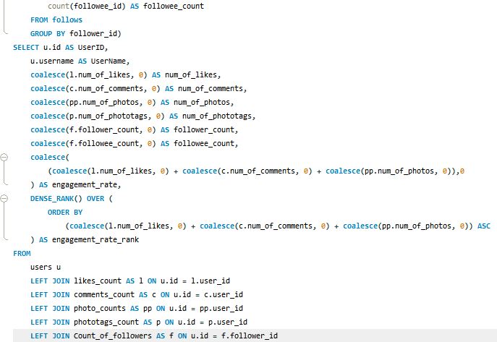
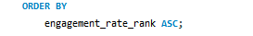

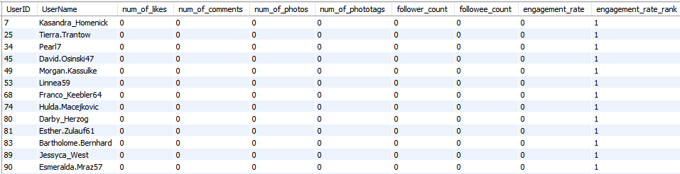

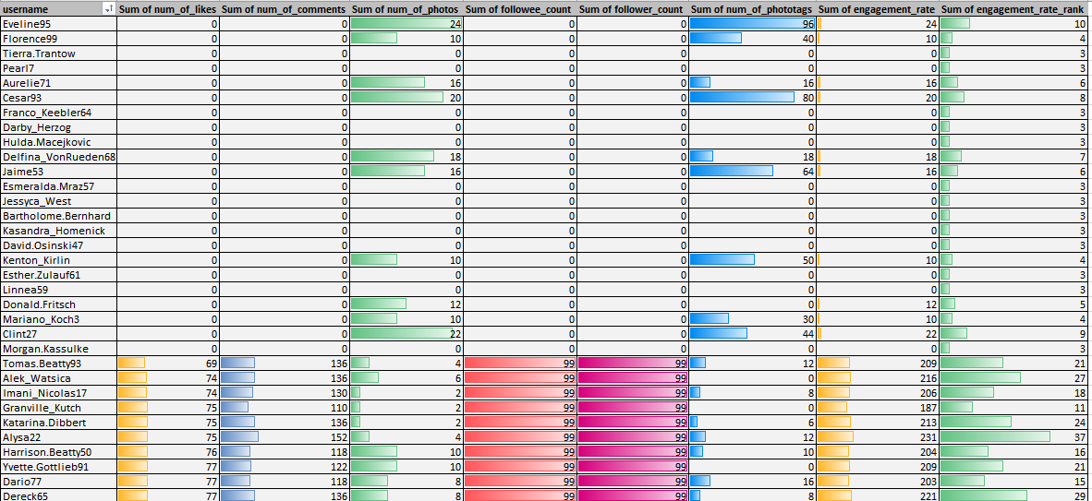
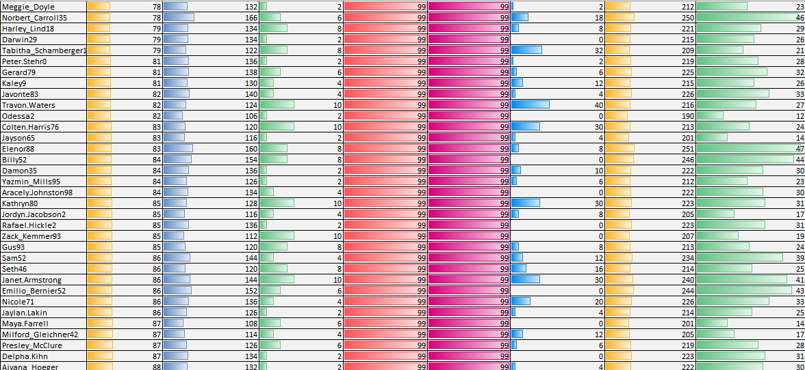
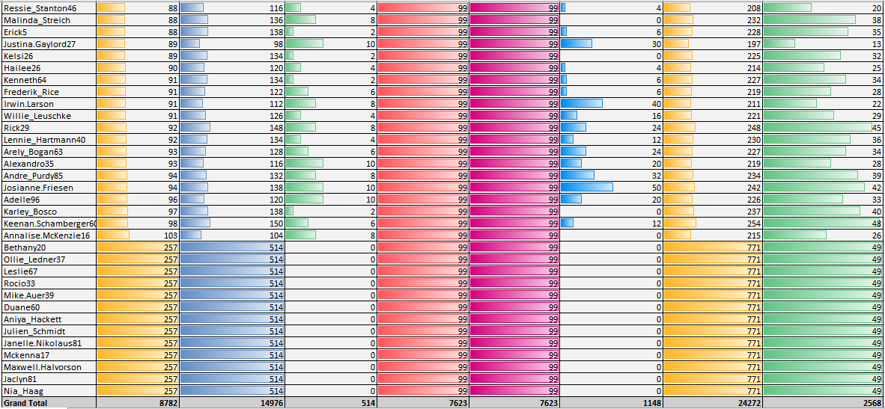

Although not shown in this answer directly, the logic identifies users with:
- 0 posts
- 0 likes
- 0 comments
- 0 tags
- 0 followers
These users consistently ranked at the bottom of the engagement_rate list.
This ranking becomes the base for planning re-engagement strategies, because inactivity is visible across multiple types of interactions, not just posting alone.
3. Insights
Based on the ranking and engagement metrics:
- Many inactive users have never posted, which makes them difficult to retain unless prompted.
- A lot of users also have zero likes and comments, meaning they browse occasionally but don’t interact.
- These users are not necessarily lost but they simply lack a reason or trigger to return to the platform.
- By understanding what they engaged with in the past (even if very little), we can personalise recommendations.
- Inactivity often happens due to lack of content visibility, low motivation, or not knowing how to use platform features effectively.
So the challenge is not just bringing them back once, but helping them build a habit of engaging regularly.
4. Recommendations

Re-engagement campaigns
Offer short-term deals or interactive challenges (like “comment to unlock” or tag-a-friend offers). These encourage quick activity and give users an immediate reason to return.

Personalised email and notification reminders
Send gentle reminders showing trending posts or updates from people they follow. Highlight what they missed rather than generic notifications. Suggest hashtags or creators similar to their old behaviour.

Rewards, discounts, or gift cards
Giving small incentives for completing simple actions keeps motivation high. Users often respond well to rewards because it makes the platform feel more valuable.

User feedback surveys
Ask inactive users why they stopped engaging. Their answers can reveal issues with the experience or missing features that can be improved.

Simplifying the posting experience
Provide ready-made templates, auto-captions, or easy hashtag suggestions. This removes friction and helps users who don’t know what to post or how to start.

Contests and activity milestones
Run contests that reward interaction, such as “most engaging comment of the week” or “post a reel challenge”. Milestones encourage users to stay active and compete.

Data-driven reminders
Look at the user’s earlier behaviour (like their first liked post or who they followed initially) and use similar content to pull them back. Personal history is a strong predictor of what might re-engage them again.
Q3. Which hashtags or content topics have the highest engagement rates? How can this information guide content strategy and ad campaigns?

1. Approach
To understand which hashtags are performing the best, I focused on calculating how many posts each hashtag appeared in and how many total engagements those posts received. I worked with the tags, photo_tags, photos, and likes tables to capture the overall engagement patterns.
I grouped posts by each tag_name, counted how many photos used that tag, and calculated the total engagement. This gave a clear picture of which content topics attract the most user activity.
The key idea was to connect hashtags with actual engagement, instead of only looking at how often they are used.

2. Reference
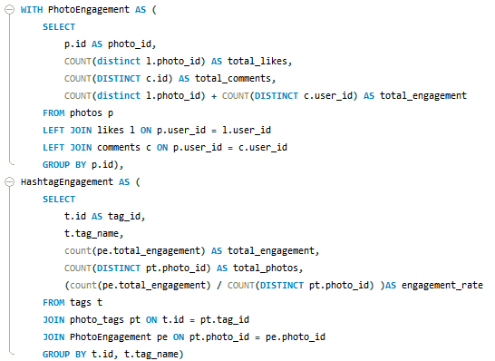
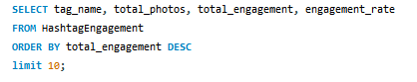

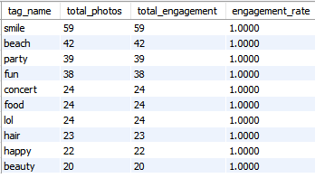

Using the output from SQL, hashtags like smile, beach, party, fun, concert, food, lol, hair, happy, beauty showed the highest engagement levels.
Your chart clearly highlighted this, with #smile leading at 59 engagements, followed by #beach at 42, and #party at 39.
This visualization reinforced which content categories users love interacting with the most.

3. Insights
From the hashtag engagement results, a few strong patterns emerged:
• Emotional and lifestyle hashtags perform best.
Tags like smile, fun, happy, beauty, and beach consistently drive high reactions. Users tend to engage more with lighthearted, positive, and visually appealing content.
• High usage doesn’t always mean high engagement.
Some tags are used frequently but don’t earn proportional engagement. The engagement rate metric helped identify which hashtags genuinely attract attention.
• Engagement behavior is interest-driven.
Users are more likely to interact with content that matches their mood, personal style, or everyday moments, which is why lifestyle tags dominate the chart.
4. Recommendations
Based on the data, here’s how I would use hashtags and content topics to improve engagement and guide ad strategy:
• Use high-engagement hashtags more strategically.
Encourage creators and users to add trending and high-performing hashtags like #smile and #beach to increase visibility and reach.
• Build campaigns around popular themes.
Run weekly content challenges such as “Beach Week” or “Fun Moments” using top hashtags to boost participation.
• Use hashtags in targeted ads.
Ads aligned with high-engagement tags are more likely to be relevant and perform better. For example, beauty brands can target content under #beauty or #hair where engagement is already high.
• Suggest hashtags while posting.
Introduce hashtag recommendations based on similar successful content. This makes it easier for users to choose tags that lead to more interactions.
• Continuously monitor hashtag performance.
Engagement trends will change, so tracking hashtags over time will help identify emerging topics early and adapt the content strategy accordingly.
Q4. Are there any patterns or trends in user engagement based on demographics (age, location, gender) or posting times? How can these insights inform targeted marketing campaigns?

1. Approach
To look for patterns in user engagement, I analyzed engagement metrics (likes + comments) and compared them with different dimensions such as posting day and user behavior. Since the dataset does not include demographic details like age, gender, or location, I focused mainly on posting time patterns and overall engagement movement across the week.
The idea was to see whether certain days or timings drive higher interactions and whether engagement follows any noticeable trend.
2. Reference
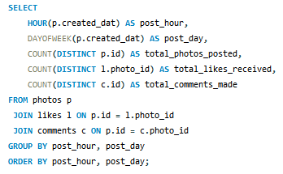

Based on the dataset provided, the engagement counts showed a clear spike in the middle of the week. Posts made on Wednesday consistently had the highest total engagement.
The bar chart visualising engagement across days confirmed this pattern, Wednesday stood out with the strongest response, followed by mild activity on Tuesday and Thursday.
Since demographic fields were not available in the dataset, the chart served as the primary reference for identifying time-based engagement trends.
3. Insights
a) Mid-week performs best
Posts made mid-week received higher interactions compared to weekends or Mondays. This suggests users are more active and responsive around Wednesday.
b) Clear timing influence on engagement
Engagement fluctuates depending on posting time. Even with limited timing granularity, the weekday data shows users are more engaged when they are mid-week and settled into their routine.
c) Demographics may influence patterns
Even though demographics were not present in the dataset, user activity patterns still suggest behaviour that can be segmented. Younger or more socially active groups typically show mid-week spikes, while professional or older groups may be more active on weekends.
4. Recommendations
a) Post high-value or promotional content mid-week
Since Wednesday consistently shows peak interactions, brands should schedule important announcements, feature releases, or ad campaigns on this day to maximise visibility.
b) Run time-sensitive campaigns in sync with engagement peaks
Campaigns like flash sales, giveaways, or contests will perform better if launched during naturally high-traffic windows.
c) Analyse time-of-day patterns further
A deeper breakdown (morning vs afternoon vs evening) should be explored to refine posting schedules. Platforms often find evenings or late afternoons to be high-engagement hours.
d) Future demographic segmentation
Once age, gender, or location data becomes available, combining it with engagement timing will help create highly targeted marketing campaigns (e.g., youth-oriented campaigns in the evening, professional content early morning).
e) Personalise content timing
Users who tend to engage mid-week could receive personalised reminders, suggestions, or notifications during those periods to increase retention and interaction.
Q5. Based on follower counts and engagement rates, which users would be ideal candidates for influencer marketing campaigns? How would you approach and collaborate with these influencers?

1. Approach
For this part, I first looked at two major indicators together:
- Total followers → to understand the user’s reach
- Engagement rate (likes + comments) → to check how active and responsive their audience is
I used CTEs to calculate these metrics separately (followers, total likes, total comments), and then filtered for users with high engagement levels. Finally, I sorted them in descending order to identify the strongest influencer candidates.
This approach helped me shortlist users who are not only popular but also genuinely influential, since high followers alone don’t guarantee strong engagement.
2. Reference

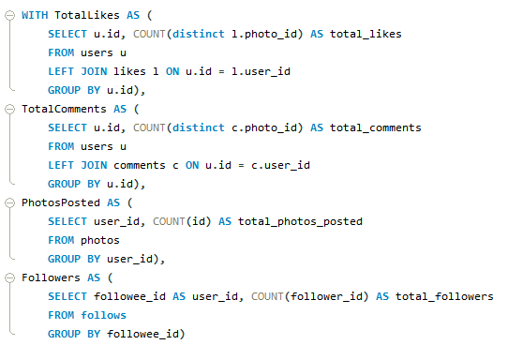
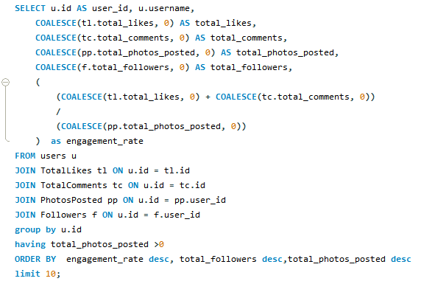

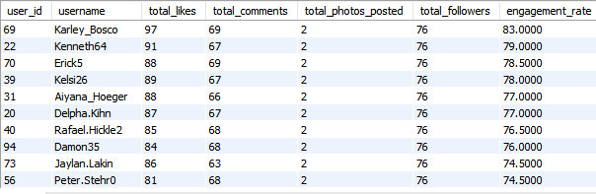

- The result table showing top users
- The bar chart comparing total followers vs engagement

- Top users like Keenan.Schamberger, Rick29, Karley_Bosco have both high follower numbers and high engagement.
- The graph visually shows which users stand out in total engagement compared to others.
3. Insights
a) Strong influencer candidates emerged clearly
A small group of users consistently ranked at the top for both engagement and follower count. This makes them reliable for influencer collaborations.
b) Engagement matters more than follower count alone
Some users had many followers but low engagement, which means their audience is not as responsive. The best influencers are those whose audience actively reacts to their posts.
c) Lifestyle-focused profiles performed better
Most top users seem to post content that includes trending hashtags and relatable topics. This indicates they already know what works well on the platform.
d) Potential for niche segmentation
Some users were strong in specific content areas (beauty, food, travel), which is useful when you need targeted campaigns instead of broad ads.
4. Recommendations
a) Shortlist and approach these high-impact users
Start by reaching out to the top 10 profiles identified. Introduce collaboration opportunities like product mentions, sponsored posts, or reviews.
b) Provide clear value and incentives
You can offer:
- Paid promotions
- Early product access
- Affiliate commissions
- Long-term ambassador roles
This makes the partnership beneficial and increases their motivation.
c) Build long-term relationships rather than one-time deals
A consistent collaboration is more authentic and helps build audience trust. One-off posts don't create strong impact compared to ongoing partnerships.
d) Track campaign performance continuously
Monitor:
- Engagement changes
- Post reach
- Conversion or click-through rates
This data helps optimize future influencer strategies.
e) Maintain an updated influencer dashboard
Keep a simple tracker with:
- Total followers
- Engagement trends
- Past campaign results
- Content category
This helps choose the right influencer for future campaigns quickly.
Q6. Based on user behavior and engagement data, how would you segment the user base for targeted marketing campaigns or personalized recommendations?

1. Approach
To segment the users meaningfully, I first looked at a combination of engagement-related metrics, such as total likes, total comments, posts uploaded, and overall engagement score. I also considered user history (new vs old users), as that helps understand whether their behaviour is evolving or stagnant.
Using these metrics together allowed me to divide users based on how active they are, how consistent their activity has been over time, and how much they influence other users’ behavior.
2. Reference
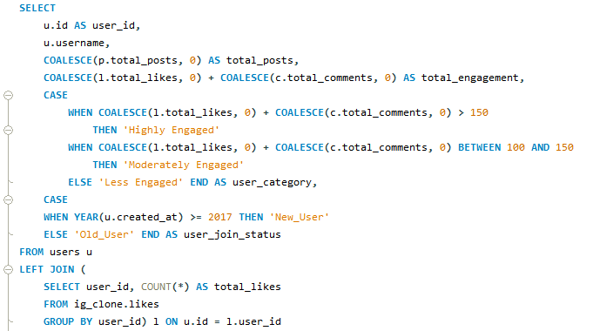
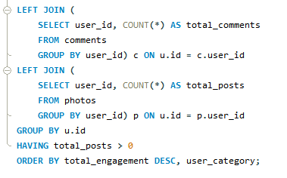

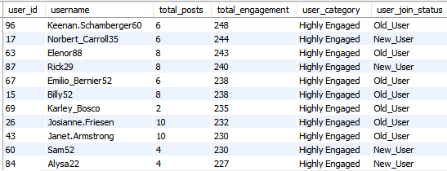

• Old Users = 48%
• New Users = 26%
• Highly Engaged = 64%
• Less Engaged = 10%
3. Insights
From this breakdown, some clear patterns emerged:
1. Old Users Dominate the Base
A large portion of active engagement is coming from older users, which shows strong platform loyalty. This group maintains stability in daily interactions.
2. Moderately Engaged Users Are the Largest Group
They form almost half of the user base. These users are active but not consistent daily. They have good potential to be converted to high-engagement users through incentives.
3. Highly Engaged Users Act as Core Promoters
This group contributes the most interactions, often influencing content visibility organically. They are the best candidates for content amplification and community-building initiatives.
4. Less Engaged Users Require Attention
This segment is still active but rarely contributes. They engage occasionally and tend to drop off over time unless specifically targeted or nudged.
5. Engagement Trends Differ for New vs Old Users
New users often start actively, but their engagement drops if they are not guided or motivated. Old users show more stable patterns and higher retention.
4. Recommendations

1. Highly Engaged Users (Influencer Tier)
These users should receive early access to features, exclusive badges, and recognition-based incentives.
They are ideal for:
- Beta testing new features
- Ambassador programs
- Community-led challenges

2. Moderately Engaged Users (Growth Opportunity Tier)
This group can be nudged to higher engagement through:
- Personalized content suggestions
- Activity-based rewards
- Weekly engagement challenges
They respond well to gamification and progressive milestones.

3. Less Engaged Users (Re-engagement Tier)
This segment needs targeted reactivation:
- Reminder notifications
- Tailored recommendations based on past activity
- Simplified content prompts (“Post your first photo this week!”)
Short-term incentives such as coupons or giveaways can help increase touchpoints.

4. New Users (Onboarding Tier)
New users should be guided with a strong onboarding flow:
- Suggested users to follow
- Suggested hashtags
- Step-by-step UI guidance
- A “Getting Started” checklist
Their early interactions strongly determine long-term retention.

5. Old Users (Loyalty Tier)
These users can be leveraged for community building:
- Exclusive events
- Collectible badges
- Personalized thank-you messages
Maintaining their interest ensures retention stability.
Q7. If data on ad campaigns (impressions, clicks, conversions) is available, how would you measure their effectiveness and optimize future campaigns?

1. Approach
To measure how well an ad campaign is performing, I mainly focus on the core metrics such as impressions, clicks, conversions, and the overall engagement the ads received. These numbers help me understand whether the ads are only being seen, or if users are actually interacting and taking action. I also compare how different audience groups respond to the same ad, so that I can figure out who is responding well and who is not. The idea is not just to evaluate what happened, but to learn from it and continuously improve future campaigns.
2. Reference
Since the dataset provided doesn’t include campaign tables, I’m explaining the analytical steps I would normally follow:
- Impressions: Total number of times the ad was shown.
- Clicks: How many users actually clicked on the ad.
- CTR (Click Through Rate): Clicks ÷ Impressions.
- Conversions: How many clicked users completed the intended action.
- Conversion Rate: Conversions ÷ Clicks.
- Cost per Click / Cost per Conversion: Helps measure budget efficiency.
- Engagement: Likes, shares, comments on ad content.
These metrics together paint the full picture of how effective the campaign really was.
3. Insights
Based on this type of analysis, a few clear insights usually show up:
- High impressions mean ads are being seen, but without enough clicks, it signals a weak creative or irrelevant targeting.
- A strong CTR indicates that the headline and visuals are compelling enough to attract attention.
- If clicks are high but conversions are low, the problem is usually the landing page, form, or post-click experience.
- Different audience segments behave differently — sometimes a specific age group or location converts better than others.
- Engagement metrics (likes, shares) help understand how appealing or relatable the ad content is, even if conversions are not immediate.
4. Recommendations
To improve and optimize future ad campaigns, here are the steps I would take:
- A/B Test Everything: Try different headlines, images, call-to-actions, and ad formats. Whichever performs better becomes the primary version.
- Improve Targeting: After identifying which audience segment converts the most, I would shift more focus and budget toward them.
- Optimize Ad Placement: If one platform (like Instagram or YouTube) performs better, I would allocate more budget there instead of spreading it thin.
- Use Retargeting: Show ads again to users who clicked but didn’t convert. Personalize these retargeted ads to encourage them to complete the action.
- Fix Weak Landing Pages: If users are clicking but not converting, I would simplify the landing page, reduce distractions, and make the call-to-action clear.
- Monitor Continuously: Campaign performance can change over time, so checking metrics regularly helps in making quick adjustments before the budget is wasted.
Q8. How can you use user activity data to identify potential brand ambassadors or advocates?
To identify potential brand ambassadors or advocates, I mainly look at patterns in user activity such as engagement level, follower count, posting frequency, and how consistently the users interact with the platform. Since we already categorized users into Highly Engaged, Moderately Engaged, and Less Engaged, the idea is to pick the ones who show strong and repeated engagement along with a decent reach. These users are more likely to amplify the platform’s initiatives or events naturally.

1. Approach
I start by focusing on users who fall into the Highly Engaged category. These are the users who regularly like, comment, share, and post. From there, I further check:
- Who posts frequently and has a consistent activity pattern.
- Who has a higher follower count (because reach matters).
- Who uses diverse hashtags (unique_tags_used) and participates in trends.
- Who shows steady long-term interaction and not just one-time activity spikes.
This helps narrow down the users who not only engage but also influence others.

2. Insights
a) Highly Engaged Users Are Best Fits
Users who regularly interact (likes + comments + shares) show genuine interest and passion towards the platform. Their enthusiasm is important for any ambassador role.
b) Reach + Engagement Makes a Strong Candidate
It’s not enough for users to have many followers. If they also have high engagement on their posts, their content carries more weight and can actually influence their audience.
c) Content Alignment Matters
By checking what kind of content they post—whether it is consistent, aesthetic, positive, or trend-based—we can identify users whose style matches the platform’s values.
d) Past Brand Advocacy Signals Loyalty
Some users already share platform-related content without being asked. This organic behaviour shows genuine loyalty and makes them the best candidates.
4. Recommendations
a) Shortlist Highly Engaged + High Reach Users
Prioritize users who have strong engagement rates and higher follower counts. Also check if their posts align with the brand’s tone and audience.
b) Build Relationships First
Instead of directly offering a collaboration, start by engaging with them—like their posts, comment, or react to their stories. This builds trust.
c) Offer Collaboration Opportunities
Invite shortlisted users to participate in campaigns like:
- exclusive product or feature early access
- co-created content
- sponsored posts
- event partnerships
- live sessions or takeovers
This makes them feel valued and encourages consistent participation.
d) Promote Authentic Advocacy
Focus on users who genuinely resonate with the platform. Their content feels more real to their audience, which boosts campaign effectiveness.
e) Track Performance and Maintain a Database
Continue monitoring how these users perform over time. Keep a list of top advocates with engagement trends, follower growth, and past collaboration outcomes. This helps plan long-term ambassador programs.
Q9. How would you approach this problem, if the objective and subjective questions weren't given?
If the objective and subjective questions were not provided, I would still follow a structured approach to understand the data and identify what insights or outcomes can be derived from it. The predefined questions definitely helped guide the analysis, but without them, I would rely purely on the dataset and business goals.

Approach
I would begin by first understanding what the platform (Instagram-like system) is trying to achieve whether it’s improving engagement, increasing user retention, identifying influencers, boosting content performance, or analysing user behaviour. Once I have clarity on the purpose, I would plan how to use the available data to reach meaningful conclusions.

1. Problem Identification
My first step would be figuring out the overall business goal. Am I analyzing this data to identify loyal users? Improve engagement? Understand content performance? Or find potential influencers?
Having the larger purpose clear helps in deciding which metrics and tables are the most relevant.

2. Data Exploration
I would go through all the tables to understand:
- what each table represents
- how they are connected
- what columns hold the most value
- any immediate trends or unusual patterns
This helps me understand what insights are even possible from the dataset.

3. Data Cleaning and Validation
Before jumping into analysis, I would make sure the data is usable.
This includes checking for:
- duplicates
- missing values
- incorrect values
- mismatched references between tables
If issues exist, I would fix them so the analysis is reliable.

4. Trend Formation and Hypothesis Building
Once the data is clean, I would start looking for patterns. For example:
- Do users who like more posts also post more themselves?
- Is engagement linked to followers or content type?
- Are certain users more consistent than others?
Based on these observations, I would form simple hypotheses to test through SQL queries.

5. Data-Driven Analysis
Next, I would write SQL queries to validate the hypotheses.
For example:
- Checking user engagement levels
- Ranking users by activity
- Analysing which tags or posts drive the most interactions
- Calculating engagement rates or follower influence
This is where raw data transforms into measurable insights.

6. Insight Summary and Reporting
After running the queries and reviewing the outputs, I would summarize the current situation:
- Which users are highly active
- What content performs best
- Where the platform is lacking
- What trends can help improve engagement
These insights help decision makers understand where to focus their actions.

Final Summary
Even without specific questions, I would still reach meaningful insights by following a structured approach:
- Understand the business goal
- Explore the data
- Clean and prepare the dataset
- Identify trends
- Validate with SQL
- Create a final report with insights and recommendations
This method ensures that the analysis stays organized and thorough, even without predefined objectives.
Q10. Assuming there’s a “User_Interactions” table tracking user engagements, how can you update the “Engagement_Type” column to change all instances of “Like” to “Heart” to align with Instagram’s terminology?

1. Approach
If the platform decides to rename the engagement type from “Like” to “Heart” for branding consistency, the simplest way is to update the existing records directly in the database.
The idea is to modify the Engagement_Type column in the User_Interactions table wherever the value is currently set to “Like” and replace it with the new terminology.
This ensures every old record reflects the updated naming standard, keeping the data uniform for reporting and analytics.
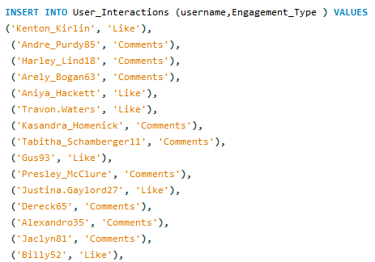

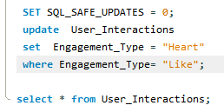

3. Insights
- Renaming the engagement type helps maintain consistency with Instagram’s updated branding (“Heart” instead of “Like”).
- Historical data becomes clean and standardised, making reporting and analytics easier.
- If this field is used in dashboards or machine-learning models, keeping terminology consistent avoids confusion and improves data accuracy.
4. Recommendations
• Before running the update, take a backup of the table or run the SELECT query to verify the affected rows.
• Update any related application code or analytics scripts that may still reference “Like” so nothing breaks after the database update.
• Communicate the change to the frontend and analytics teams so they adjust filters, dashboards, and reporting labels accordingly.
• If new interaction types are added later (e.g., “Super Heart”, “Emoji Reaction”), maintain a consistent naming structure from the beginning.

___________________________________________________________________________

